Choose custom reports over Workday® standard delivered reports

Workday standard delivered reports are not as useful because you cannot see how it is pulling data. So, if you run a report and get questionable results you are not empowered to immediately understand why. Custom reports allow you to articulate the fields from which data is pulled.

 It is best to create a custom report starting from a Workday delivered report. This is good way to start because this task allows you to see how the standard report is pulling data and then you can customize to your institution.

Edit Custom Report task
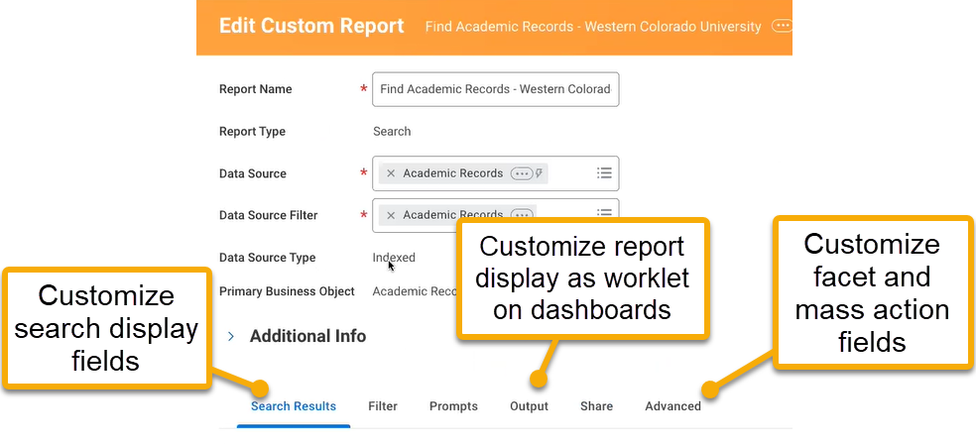

Custom search display fields in the Search Results tab
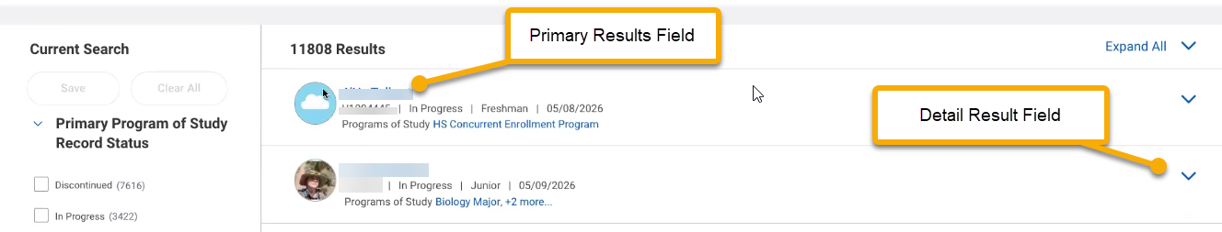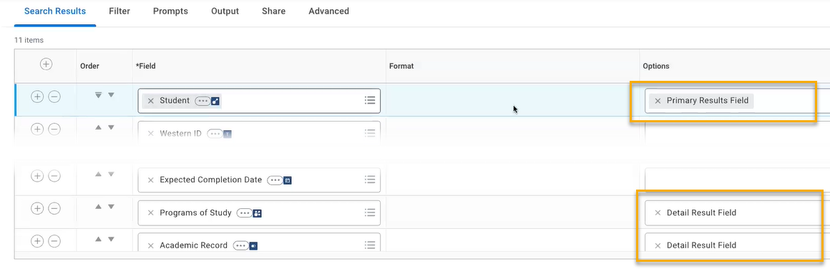

Custom search report facets and mass actions in the Advanced tab

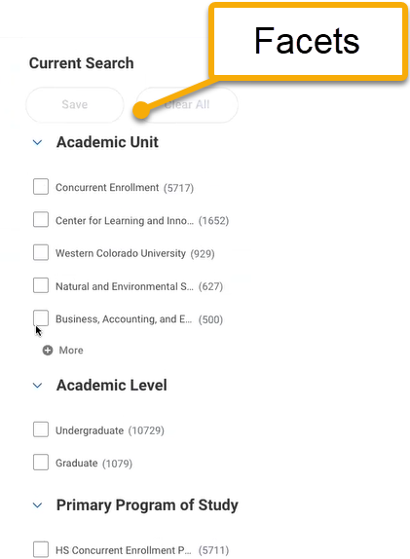
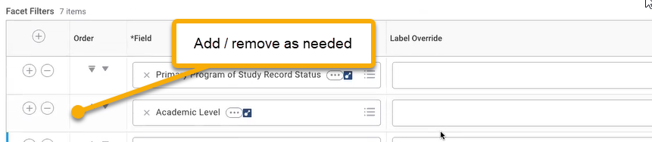
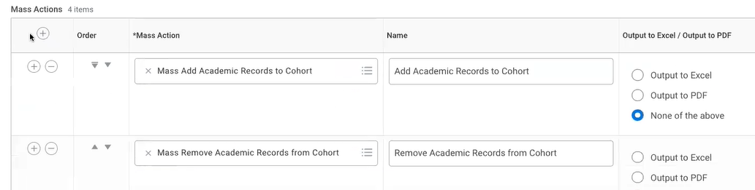

Customize worklet display in the Output tab
